Supporting information
Glass Transition Temperature Prediction in Lignin Polyurethanes Using Machine Learning on Small Experimental Dataset

Silviu Florin Acaru¹, Marc Comí², Panagiotis Falireas², Danny E. P. Vanpoucke^{3,4}, Richard Vendamme², Katrien V. Bernaerts¹*
¹ Sustainable Polymer Synthesis group, Aachen-Maastricht Institute for Biobased Materials (AMIBM), Faculty of Science and Engineering, Maastricht University, Brightlands Chemelot Campus, Urmonderbaan 22, 6167 RD Geleen, the Netherlands
² Sustainable Polymer Technologies Team, Flemish Institute for Technological Research (VITO N.V.), Mol, Belgium
³ Hasselt University, Institute for Materials Research (imo-imomec), Quantum & Artificial inTelligence design Of Materials (QuATOMs), Martelarenlaan 42, B-3500 Hasselt, Belgium
⁴ imec, imo-imomec, Wetenschapspark 1, B-3590 Diepenbeek, Belgium

* corresponding author, katrien.bernaerts@maastrichtuniversity.nl

Representative DSC curve
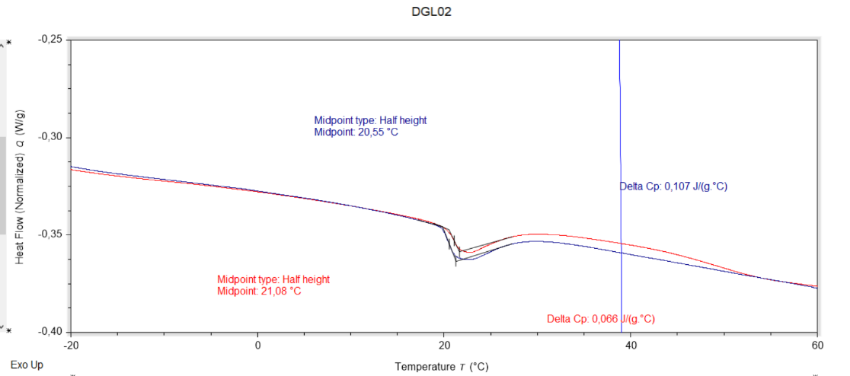
Figure S1 Representative DSC curve for a sample with sample, with a target [NCO]/[OH] ratio 0.6, HDI as the isocyanate type, PTHF 250 as the polyol, and 20% lignin content. The blue curve corresponds to the first heating cycle, the red curve to the second heating cycle. T_{g} values are determined as midpoint values from the second heating cycle.

Distribution of Swelling Ratio
The dataset was analyzed based on two primary factors: Ratio [NCO]/[OH] and Isocyanate type. Five levels of Ratio (1.4, 1.2, 1, 0.8, and 0.6) and two levels of Isocyanate (HDI and HDIt) were considered, resulting in ten distinct combinations. Each combination represents approximately 10 % of the total dataset, with percentages ranging from 8.09 % to 11.03 %, indicating a relatively even distribution among the groups.
For Ratio 1.4, the Isocyanate type significantly influenced the range of swelling ratios. With Isocyanate type HDI, swelling ratios ranged from 15.00 to 155.00 %, while with Isocyanate type HDIt, the range was more confined, extending from 21.00 to 64.00 %.
Ratio 1.2 showed similar patterns but with wider ranges. Isocyanate type HDI exhibited a range of 15.00 to 249.00 %, compared to 25.00 to 75.00 % for type HDIt. For Ratio 1.00, the difference in swelling ratio ranges between Isocyanate types was even more pronounced. HDI had a range of 24.00 to 291.00 %, while HDIt ranged from 29.00 to 108.00 %.
Ratio 0.8 continued this trend, with HDI showing a range of 6.00 to 328.00 %, compared to 19.00 to 113.00 % for HDIt. The widest ranges were observed for Ratio 0.6, where HDI exhibited a swelling ratio range of 11.00 to 472.00 %, while HDIt ranged from 7.00 to 275.00 %.
The frequency distributions demonstrated consistent patterns across ratio levels. For HDI types, the distributions typically showed right-skewed patterns, indicating that while the ranges extended to higher values, the majority of observations clustered at lower swelling ratios. In contrast, HDIt distributions consistently showed more compact ranges with lower maximum values at each ratio level.
To summarize, the data suggests that both Ratio and Isocyanate type have substantial effects on the swelling ratio. Consistently across all Ratio levels, HDI resulted in wider ranges and higher maximum swelling ratios compared to HDIt. Difunctional HDI results in a lower crosslinking density than multifunctional HDIt, explaining the higher swelling degrees that can be achieved. Additionally, as the Ratio [NCO]/[OH] decreased, the crosslinking density decreased resulting in an increased maximum swelling ratio. This increase if visible for both Isocyanate types, with the effect being more pronounced for difunctional HDI that results in less crosslinking. These findings indicate a significant interaction between the Ratio and Isocyanate type in determining the swelling behavior of the materials.

Figure S2 Distribution of Swelling ratio with respect to the Ratio [NCO]/[OH] and Isocyanate type.

Feature Selection

PCA Results
Figure S3 Cumulative variance of the PC's

Wrapper Results
The wrapper selection method, which incorporated 3 mandatory features (Lignin wt%, Co-polyol type PTHF, Ratio) and several optional features (Co-polyol wt%, Isocyanate wt%, Isocyanate mmol NCO, Isocyanate type, Tin(II) octoate, Swelling ratio %), was employed. All possible combinations of these features were tested, resulting in a total of 64 unique datasets. The performance of these datasets was initially evaluated on an Out-of-Fold (OOF) cross validation technique and evaluated using Mean Absolute Error (MAE) of the validation datasets. The results are presented I the table below:

Table S1 Out-of-Fold cross validation top 5 best performing stacked ensemble models with Swelling Ratio included
Rank | R² | MSE | MAE | Base Estimators | Key Features
1 | 0.383 | 436.24 | 15.423 | 50 | Lignin + PTHF + Ratio + Co-polyol + Isocyanate + Tin(II) octoate + Swelling Ratio
2 | 0.361 | 452.03 | 15.476 | 50 | Lignin + PTHF + Ratio + Co-polyol + Swelling Ratio
3 | 0.380 | 437.96 | 15.478 | 50 | Lignin + PTHF + Ratio + Co-polyol + Isocyanate + Isocyanate type + Tin(II) octoate + Swelling Ratio
4 | 0.353 | 458.24 | 15.498 | 1000 | Lignin + PTHF + Ratio + Co-polyol + Swelling Ratio
5 | 0.354 | 457.09 | 15.508 | 700 | Lignin + PTHF + Ratio + Co-polyol + Swelling Ratio

Table S2 Out-of-Fold cross validation top 5 best performing stacked ensemble models without Swelling Ratio as an input feature.
Rank | R² | MSE | MAE | Base Estimators | Key Features
1 | 0.337 | 468.17 | 15.714 | 700 | Lignin + PTHF + Ratio + Co-polyol + Isocyanate type
2 | 0.328 | 473.75 | 15.772 | 1000 | Lignin + PTHF + Ratio + Co-polyol + Isocyanate type
3 | 0.328 | 473.62 | 15.783 | 900 | Lignin + PTHF + Ratio + Co-polyol + Isocyanate type
4 | 0.328 | 473.73 | 15.799 | 800 | Lignin + PTHF + Ratio + Co-polyol + Isocyanate type
5 | 0.346 | 462.01 | 15.818 | 1000 | Lignin + PTHF + Ratio + Co-polyol + Isocyanate + Tin(II) octoate

,
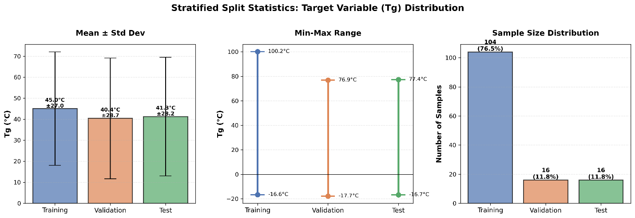
Figure S4 Stratified sampling T_{g} distribution.
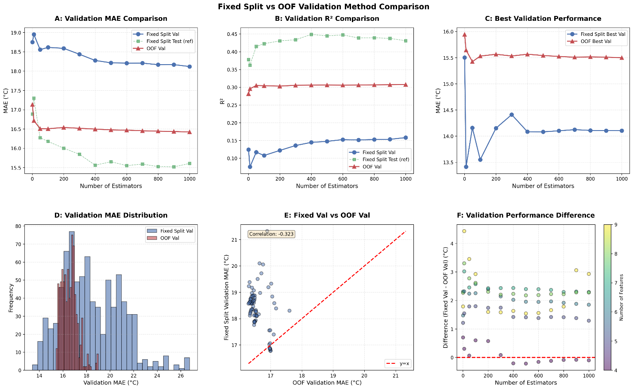
Figure S5 OOF vs stratified sampling statistical comparisons. Statistical Comparison of Validation Performance Across Hyperparameter Configurations. (A) Mean Validation MAE by n_estimators. Mean Absolute Error (MAE) averaged across all 63 model configurations per n_estimators value (10, 100, 500). Each bar represents the group mean (e.g., n_estimators = 10: MAE = 18.951 °C; n_estimators = 100: MAE = 18.615 °C; n_estimators = 500: MAE = 18.215 °C).(B) Mean Validation R² by n_estimators. Coefficient of determination (R²) averaged across all 63 model configurations per n_estimators value, following the same grouping as panel (a). (C) Best Validation MAE by n_estimators. Minimum (best) MAE achieved within each n_estimators group, representing the top-performing configuration per group rather than the group average.(D) Validation MAE Distribution. Full distribution of individual validation MAE values across all model configurations (no averaging), shown to illustrate the spread and overlap between OOF and stratified sampling approaches.

Hyperparameters
Table S3 Base models hyperparameters used during optimization. n_estimators = [1,10,50,100,200,300,400,500,600,700,800,900,1000]
GBR | n_estimators: [n_estimators]
 | learning_rate: [0.01, 0.1, 0.2]
 | max_depth: [3, 5, 7]
RF | n_estimators: [n_estimators]
 | max_depth: [None, 10, 20]
 | min_samples_split: [2, 5, 10]
SVR | C: [0.1, 1, 10]
 | kernel: ['rbf', 'linear']
 | gamma: ['scale', 'auto']
Lasso | alpha: [0.1, 1, 10]
 | max_iter: [1000, 5000]
ElasticNet | alpha: [0.1, 1, 10]
 | l1_ratio: [0.1, 0.5, 0.9]
 | max_iter: [1000, 5000]

Values Distribution

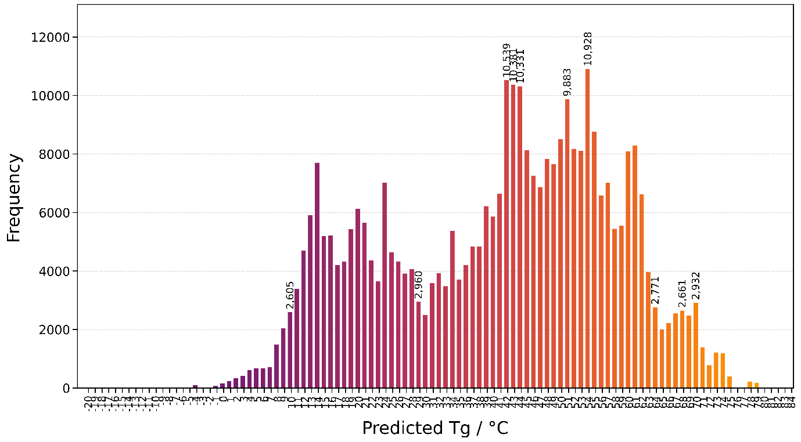
Figure S6 Distribution of predicted T_{g} values of the mapped results. Annotation counts are shown for the five T_{g} values: for top, median and lower data points.

Applicability Domain Analysis
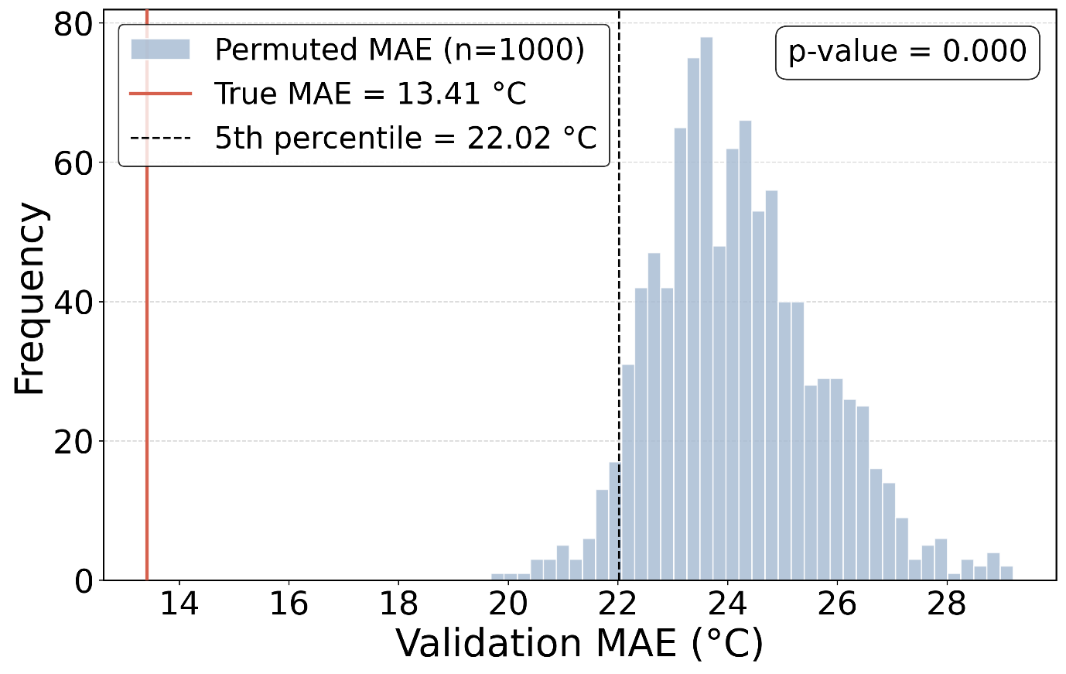
Figure S7 Permutation test for the stacking ensemble. The histogram shows the distribution of validation MAE values obtained from 1000 random permutations of the training set Tg labels. The red vertical line marks the true validation MAE (13.41 °C) and the black dashed line the fifth percentile of the permuted distribution (22.01 °C). p < 0.001, indicating that model performance is statistically significant and not attributable to chance.

